NAME : Sharatha sree R COURSE: MOBILE COMPUTING
REG NO : 192421033 COURSE CODE: ITA0301

1.Use Figma to create an interactive diagram illustrating the components of a basic cellular
system.
Aim: -
To create an interactive diagram illustrating the components of a basic cellular system
Procedure: -
1. open Figma
2. Create a new file
3. Select the Frames
4. Fill in the content that is required for presentation
5. Design Visual Elements
6. Make it Interactive
7. Add Annotations and Explanations
8. Incorporate Multimedia
9. Storyboard Animation
11. Review and edit the Prototype
12. Save and Share
Design: -
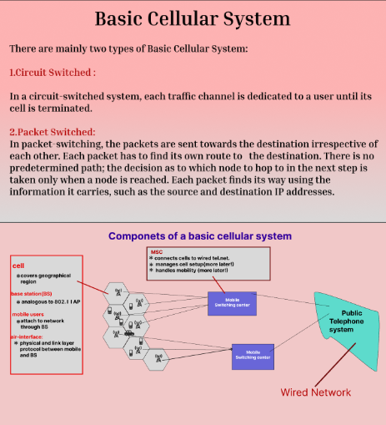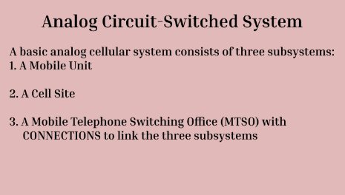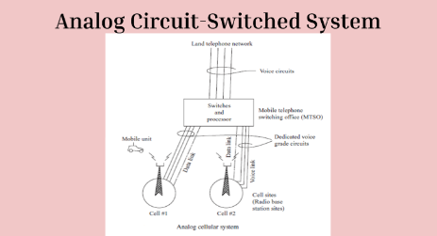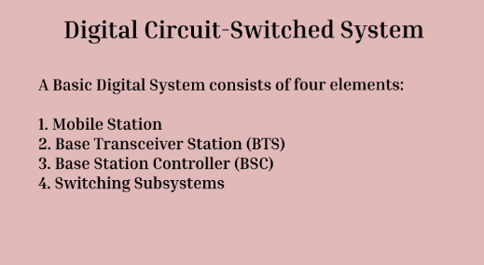
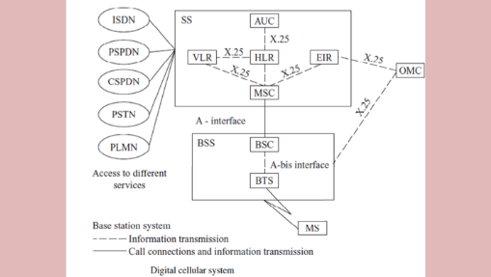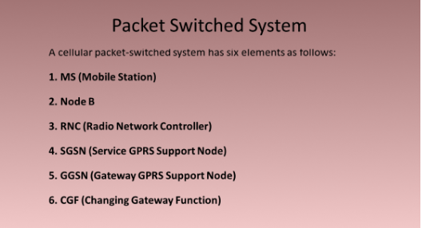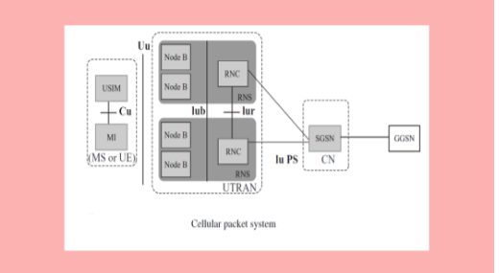

Prototype:

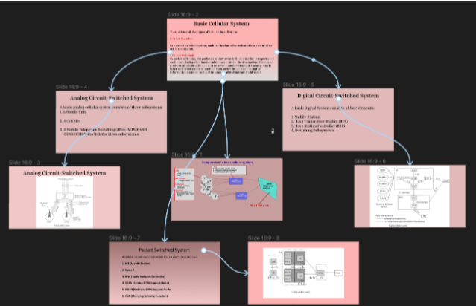

Result: -
Hence an interactive diagram illustrating the components of a basic cellular system using

Figma is created and executed successfully

